**Policy Pulse: Unveiling Insurance Solutions at Your Fingertips**

Policy Pulse: Unveiling Insurance Solutions at Your Fingertips introduces a groundbreaking approach to exploring insurance options through a cutting-edge search engine. The project is dedicated to leveraging innovative search technology to streamline the process of discovering diverse insurance solutions. By harnessing state-of-the-art algorithms and data analytics, Policy Pulse aims to empower users with an intuitive and advanced platform for seamless insurance exploration.

**Advanced Natural Language Processing:**

Policy Pulse incorporates advanced natural language processing techniques to precisely understand user queries. This feature enables users to express their insurance needs in natural language format, allowing the search engine to interpret and deliver accurate and relevant results. The integration of sophisticated language technology ensures a more user-friendly and context-aware insurance search experience.

**Customizable for Various Insurance Needs:**

Policy Pulse is designed to be highly adaptable, offering customization for various insurance domains or specialties. Whether users are seeking auto, home, health, life insurance, or specific niche areas within these categories, the platform utilizes its search technology to comprehend and retrieve domain-specific knowledge. This adaptability guarantees that users receive tailored and pertinent insurance information aligned with their individual requirements.

**Technical Architecture:**

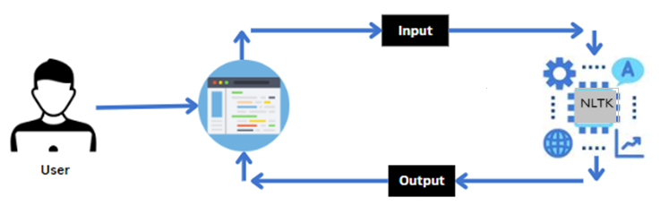

**Project Flow:**

* **Data Collection**
* Prepare a dataset of Insurance-related FAQs
* Structure data in CSV format
* **Data Preprocessing**
* Tokenize and stem text data.
* Convert text to lowercase for consistency.
* Utilize TF-IDF vectorize for textual representation.
* **Model Training**
* Implement cosine similarity metric.
* Train search engine on TF-IDF vectors.
* Save the trained model and vectorizer.
* **Application Building**
* Develop Flask application for the search engine.
* Integrate trained model and vectorizer.
* Create UI using HTML.
* **User Interaction**
* Users input insurance-related queries through UI.
* **Search Engine Functionality**
* Process user input with preprocessing steps.
* Utilize cosine similarity to find relevant questions.
* Return corresponding answers or “Not Found”.
* **Testing and Evaluation**
* Test with various queries, including those outside the dataset.
* Evaluate accuracy and user experience.
* **Deployment**
* Deploy the Policy Pulse search engine application.

**Prior Knowledge:**

You must have prior knowledge of following topics to complete this project.

* NLP:- <https://www.javatpoint.com/nlp>
* Nltk:<https://www.youtube.com/watch?v=5e67tbgqgLA&list=PLS1QulWo1RIZDws-_0Bfw5FZFmQJWtMl1&index=5>
* TFIDF Vectorizer: <https://scikitlearn.org/stable/modules/generated/sklearn.feature_extraction.text.TfidfVectorizer.html>
* Snowball Stemmer: <https://www.geeksforgeeks.org/snowball-stemmer-nlp/>

**Project Structure:**

Create the Project folder which contains files as shown below

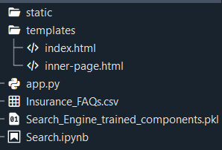

* We are building a flask application which needs HTML pages stored in the templates folder and a python script app.py for scripting.
* Search_Engine_trained_components.pkl is our saved components. Further we will use this model for flask integration.
* Training folder contains a model training file.

# Milestone 1: Data Collection & Preparation

Dataset Link:  <https://github.com/AdityaRandive/ChatBot/blob/master/BankFAQs.csv>  
From the above dataset we need to create the separate dataset with insurance FAQs.

Dataset Link: <https://github.com/chandanapendli/Insurance_Search_Engine/blob/main/Insurance_FAQs.csv>

**Activity 1: Importing the libraries**

Import the necessary libraries as shown in the image.

* Imported essential libraries such as pandas, numpy, nltk, pickle, TfidfVectorizer, cosine_similarity, and SnowballStemmer.
* NLTK's 'punkt' resource is downloaded for tokenization.
* Initializing  SnowballStemmer from NLTK for word stemming, a common technique in natural language processing.
* Use TfidfVectorizer from scikit-learn to convert text data into numerical vectors based on term frequency-inverse document frequency.

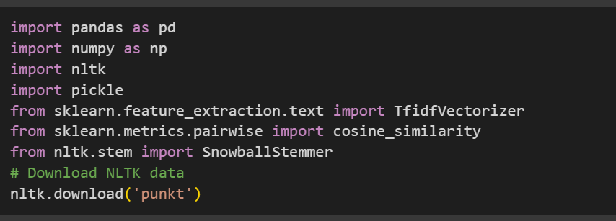

## Activity 2: Read the Dataset

Our dataset format might be in .csv, excel files, .txt, .json, etc. We can read the dataset with the help of pandas.

In pandas we have a function called read_csv() to read the dataset. As a parameter we have to give the directory of the csv file.

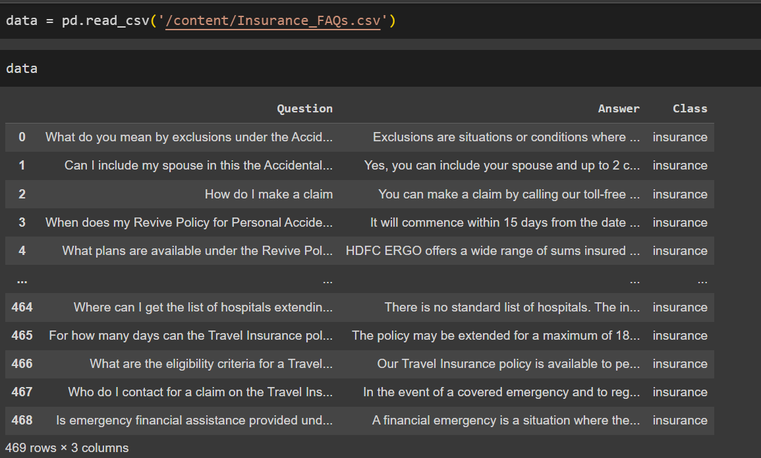

## Activity 3: Preprocessing the Data

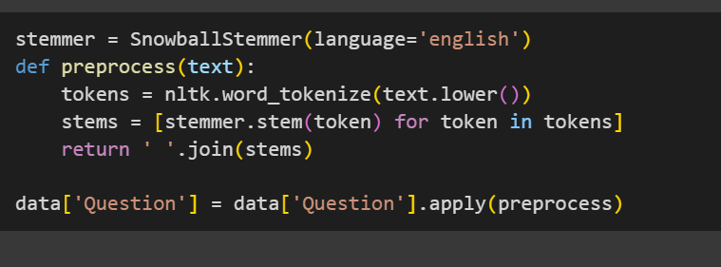

The above code lowers the text's case, splits it into words, and then reduces each word to its base form using Snowball Stemmer, which helps in standardizing words for analysis tasks like search.

**Vectorize the text data:**

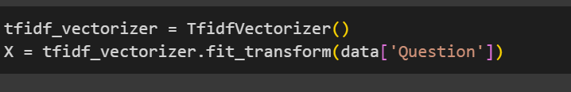

The tfidf_vectorizer instance creates a TF-IDF (Term Frequency-Inverse Document Frequency) matrix from the text data in the 'Question' column of the data. This matrix represents the importance of each word in the documents based on their frequency and rarity across all documents.

# Milestone 2: Model Building

**Activity 1: Training the Search Engine Using Cosine Similarity**

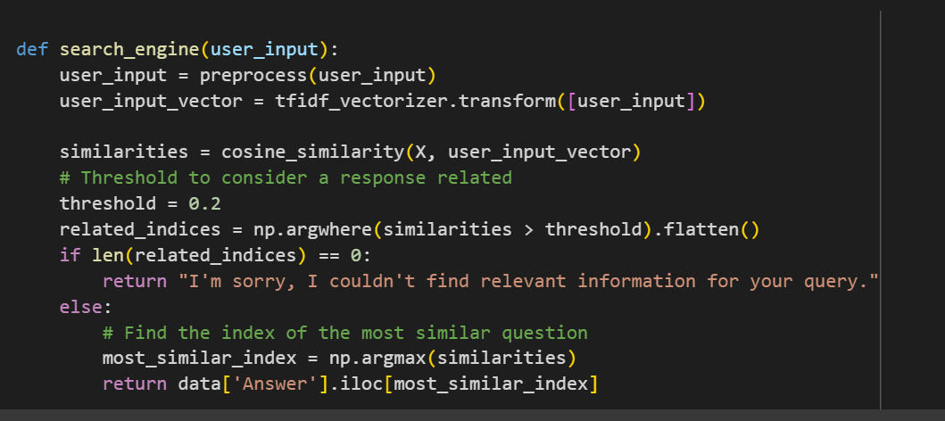

This function preprocesses the user's input and converts it into a TF-IDF vector using the same vectorizer trained on the dataset's questions.

It then computes the cosine similarity between this vector and all question vectors in the dataset to identify related questions.

If the similarity exceeds a predefined threshold, it retrieves the corresponding answer from the dataset; otherwise, it informs the user that relevant information couldn't be found.

**Activity 2: Testing the Search Engine**

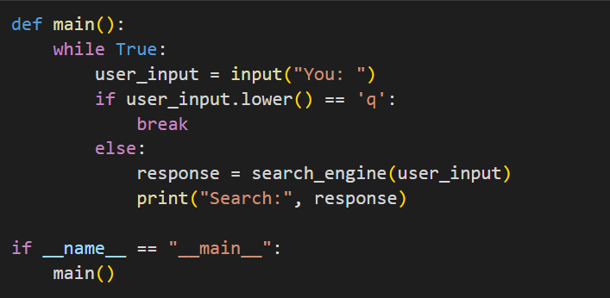

This main function continuously prompts the user for input until they enter 'q' to quit. For each input, it passes it to the search_engine function to find relevant responses and prints them.

# Milestone 3: Model Deployment

Now that we have trained our model, let us build our flask application which will be running in our local browser with a user interface.

In the flask application, the input parameters are taken from the HTML page .These factors are then given to the model to get the results from search engine  and showcased on the HTML page to notify the user. Whenever the user interacts with the UI and selects the “submit” button, the text will be displayed.

**Activity 1: Integrate with Web Framework**

* We use HTML to create the front-end part of the web page.
* Here, we have created 2 HTML pages- index.html, inner-page.html
* index.html display the home page.
* Inner-page.html displays an output about the project
* We also use  CSS-main.css to enhance our functionality and view of HTML pages.
* Link: CSS, JS

Create app.py (Python Flask) file: -

**Activity 2: Build Python code:**

Import the libraries

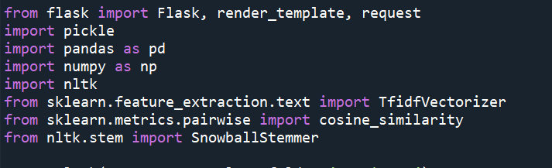

Load the saved model. Importing the flask module in the project is mandatory. An object of Flask class is our WSGI application. Flask constructor takes the name of the current module (__name__) as argument.

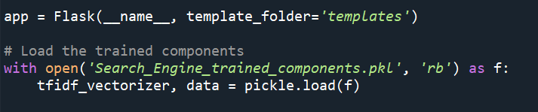

Write the below code in Flask app.py python file script to run the Search Engine project

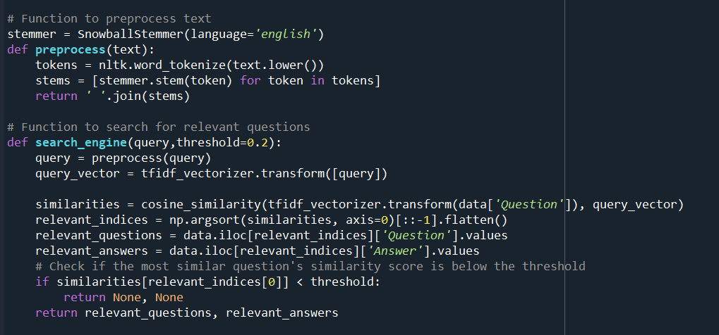

**Render HTML page:**

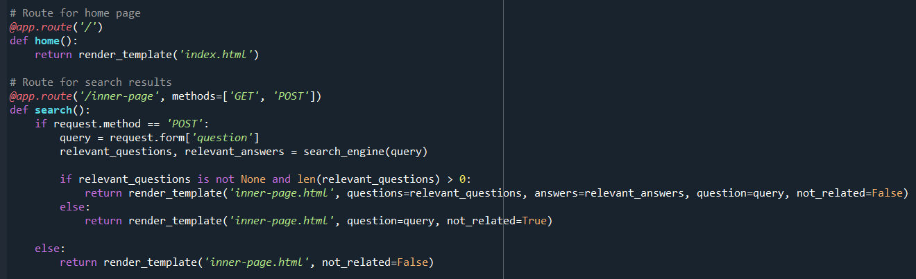

Main Function:

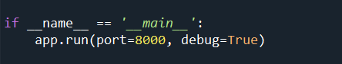

## Activity 3: Run the web application

* Open anaconda prompt from the start menu
* Navigate to the folder where your python script is.
* Now type “python app.py” command
* Navigate to the localhost where you can view your web page.

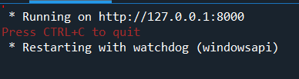

**Index.html-page:**



About:

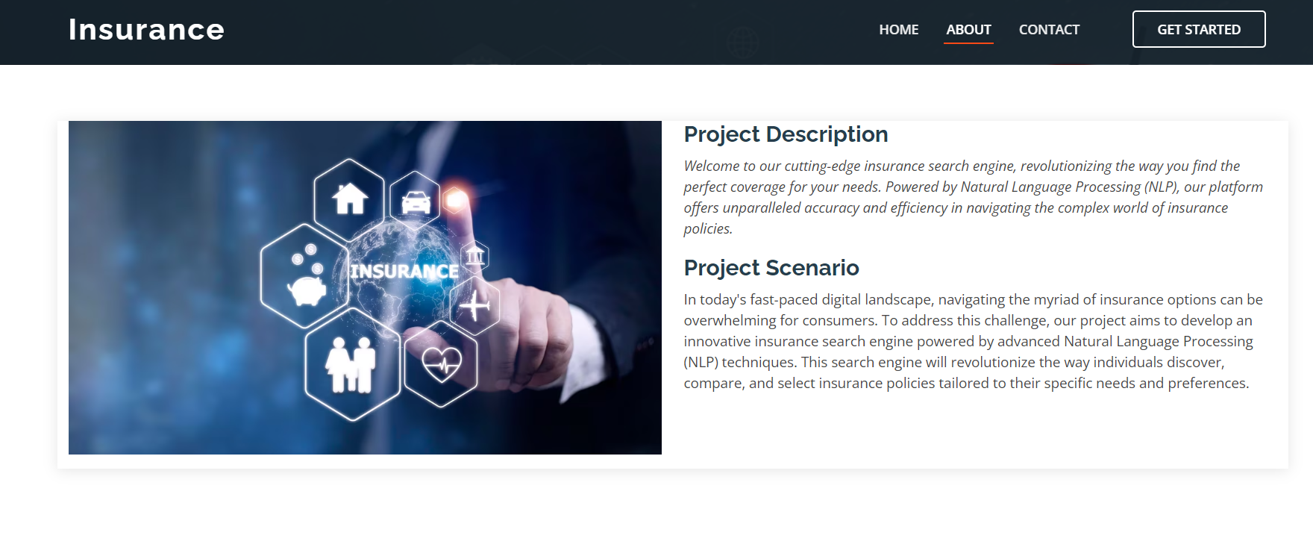

Contact:

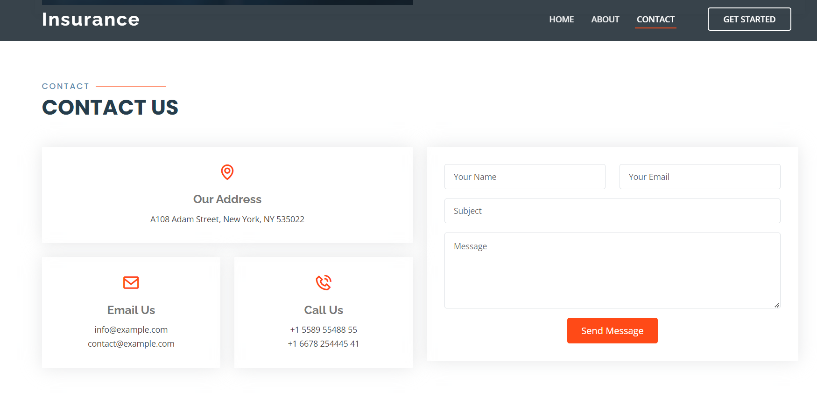

When we click on the ‘Get Started’ button it will redirect to the inner-page.html

